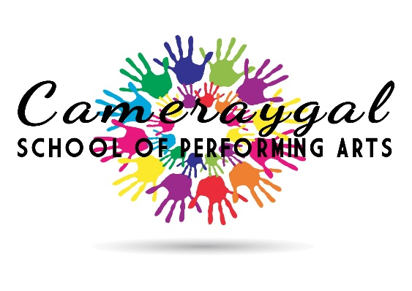
2019 Enrolment Form
First name: ____________________________________________________________________
Last name: ____________________________________________________________________
Date of birth: _____________________________ Current age: _________________________
Sex: Male Female
Address: ______________________________________________________________________
Home Phone: __________________________________________________________________
Mobile: _______________________________________________________________________
E-mail: ________________________________________________________________________
Do you have any special needs that you feel should be taken into consideration?
______________________________________________________________________________________________________________________________________________________________________________________________________________________________________________________________________________________________________________________________________________________________________________________________________

Emergency Contact Information:
Full name: _____________________________________________________________________
Relationship: ___________________________________________________________________
Contact number: _______________________________________________________________

How did you hear about Cameraygal School of Performing Arts?
____________________________________________________________________________________________________________________________________________________________
Terms and Conditions:
- Enrolments are not accepted without payment.
- Fees are non-refundable unless cancelled by Cameraygal School of Performing Arts and transfers and credits will only be considered up to 48 hours prior to the commencement of a workshop and incur a $25 administration fee.
- Cameraygal School of Performing Arts reserves the right to make amendments to its programs without prior notice either before or during a course or to cancel a course.
- Cameraygal School of Performing Arts reserves the right to merge published age groups and structure classes as required.
- All participants must follow safety instructions as we do not accept liability for personal injury.
- When booking into a Cameraygal School of Performing Arts course, participants (or their parents and guardians) acknowledge that all activities are physical and may involve the risk of accidents occurring.
- Cameraygal School of Performing Arts reserves the right to refuse admission to anyone who poses a disciplinary problem to our tutors/staff/ other students.
- Parents need to advise the school if their child has any history of medical problems that they may be aware of and tutors cannot be responsible for administering medication.
- Should staff deem necessary for an ambulance to be called the cost will be incurred by the participant or their guardian/ parent.
- Cameraygal School of Performing Arts does not accept responsibility for personal property left at a venue.
- As Cameraygal School of Performing Arts tutors are professional artists we reserve the right to make last minute substitutions if necessary.
- Cameraygal School of Performing Arts provides supervision of young people during course hours only.
- Late picks ups from School Holiday Workshops will be charged at $10 per ten minutes.
- Your personal information will be stored in accordance with current privacy legislation.
- Cameraygal School of Performing Arts reserves the right to make archival photographic and/or visual recordings of workshops for inclusion in Cameraygal School of Performing Arts’ archives and or marketing or promotional material and for use in Cameraygal School of Performing Arts’ marketing publications.
Please acknowledge the terms and conditions bound to this enrolment by ticking the following box.
* I have read, understood and agree to Cameraygal School of Performing Arts’ terms & conditions of enrolment.
* I understand that Cameraygal School of Performing Arts training is practical and I accept that there are always risks inherent in these activities.

Signed: Date:

Please complete this form and return to:
Post: Cameraygal School of Performing Arts
P.O Box 1207
Lane Cove, 1595
Email: cameraygal@outlook.com

Term fees are payable via deposit into the following account:
Account name: Cameraygal School of Performing Arts
BSB: 032085
Account Number: 455966
Please use your surname as reference ID

Enrolment will be confirmed once enrolment form and fees have been received.

